**AMERICAN INTERNATIONAL UNIVERSITY-BANGLADESH**

**Faculty of Science and Technology**



**Course Title: Data Communication[G]**

**Lab Report-5**

**Exp. Title: Study of Digital to Analog Conversion using MATLAB**

***Submitted by:* [Group-2]**

|  |  |
| --- | --- |
| **Name** | **ID** |
| Shadril Hassan Shifat | 20-42451-1 |
| Sadia Sultana Ali | 20-42386-1 |
| Abu Shaleh Md. Kaium | 20-42475-1 |
| Md. Ali Ahnaf | 20-42378-1 |

***Submitted to:* Tanjil Amin**

**Date of Submission:19 April, 2022**

**Class Task:**

**Lab Report 6**:

*** Apply amplitude modulation and demodulation on a composite signal:  
# Input Signal, it = 6*sin(2*pi*3*t) + 5*cos(2*pi*7*t) - 2*cos(2*pi*10*t);  
# Carrier Signal, ct = cos(2*pi*200*t)

**Simulink Block Diagram:**

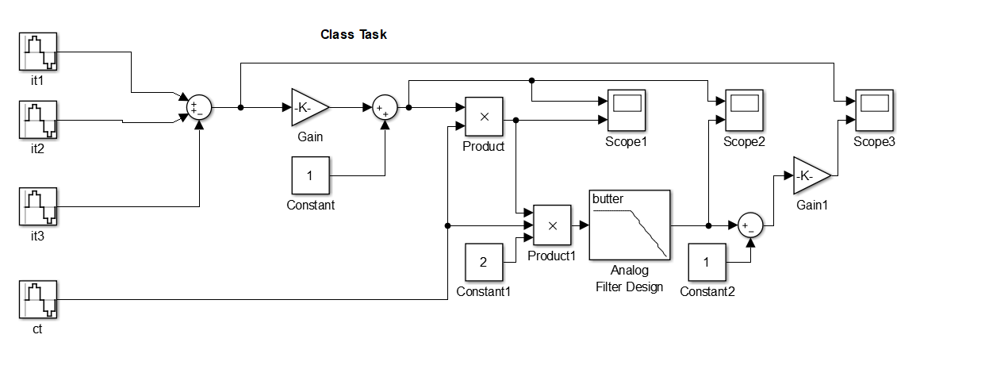

**Modulation Output Scope:**

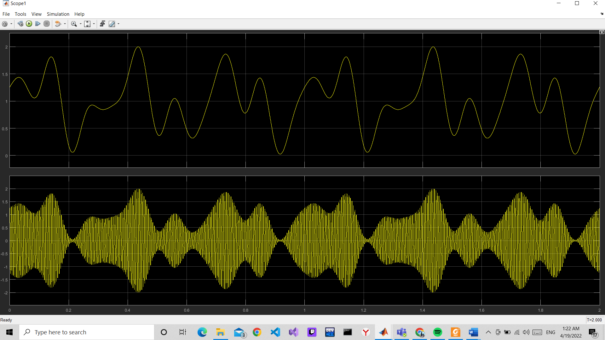

**Demodulation Output Scope:**

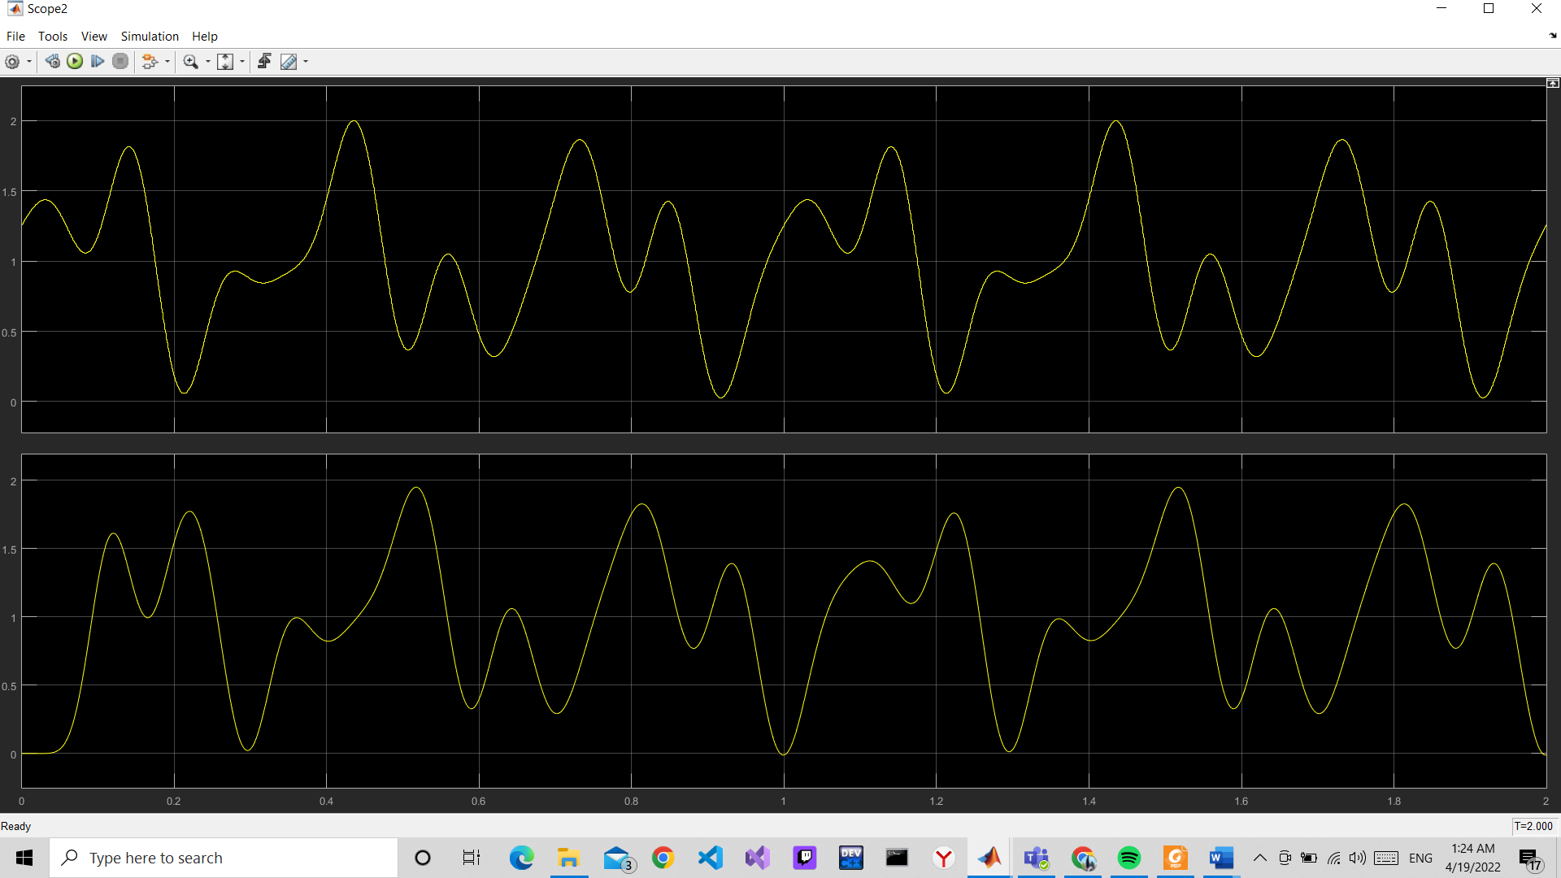

**Scope for original signal and recovered signal:**

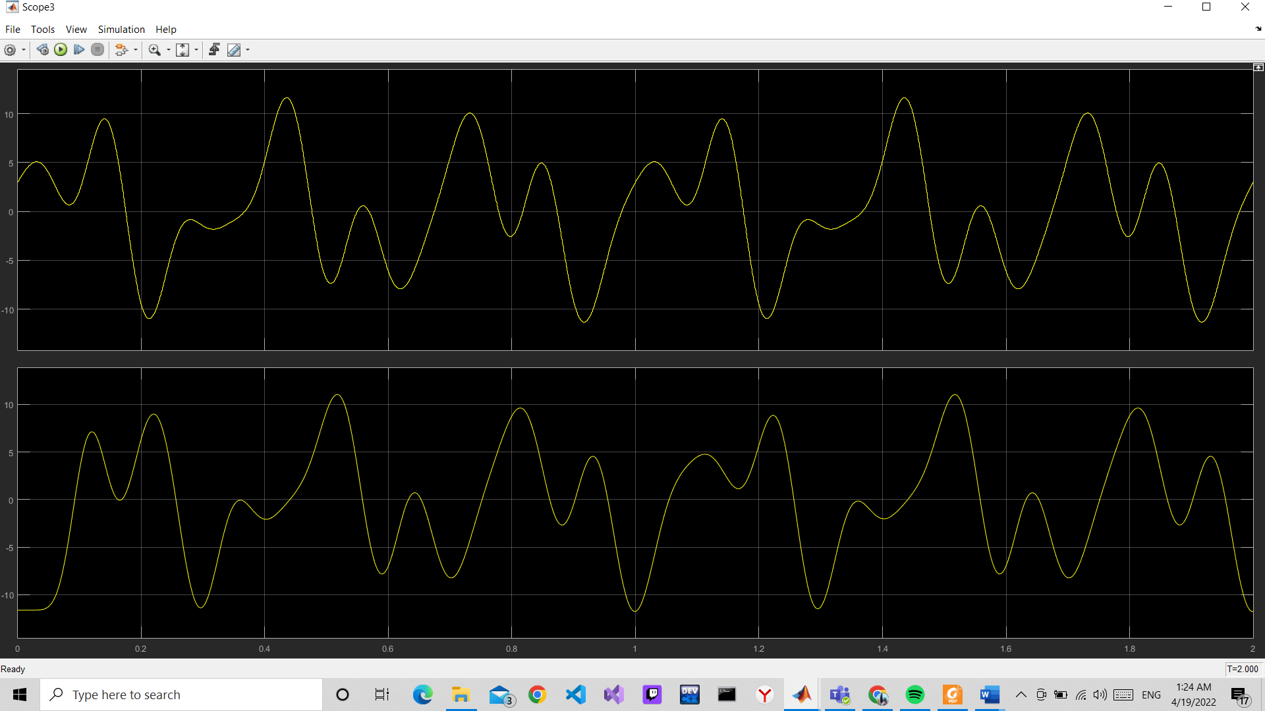

**Performance Task:  
Implement the following demodulation in Simulink to retrieve the original signal:**You have a signal ‘m(t) = (2*sin(2*pi*4*t)+3*cos(2*pi*6*t))’. Apply amplitude modulation (AM) on the given signal with carrier signal ‘c(t) = cos(2*pi*50*t)’, and then do demodulation to get back the original message signal m(t). Remember your demodulated signal should have same amplitude and frequency as m(t) has.  
• Formula for modulation: s(t) = (1+ (m(t)))*c(t)  
• Formula for demodulation: m’(t) = (s(t)*2*c(t)-1) [Remember you have to use a low pass filter here to match m’(t) with m(t)]  
• Provide five screenshots in your report. First one for modulation block, second one for demodulation block, third one for whole block, fourth one for scope with original, carrier and modulated signal, fifth one for scope with original and recovered signal.  
• Every screenshot must cover your full monitor screen.  
• Your Name, ID, and Section must be visible in every screenshot.

**Simulink Block Diagram:**

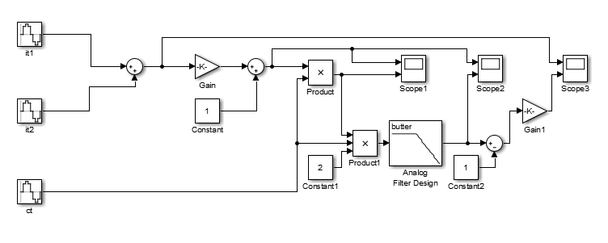

**Modulation Output Scope:**

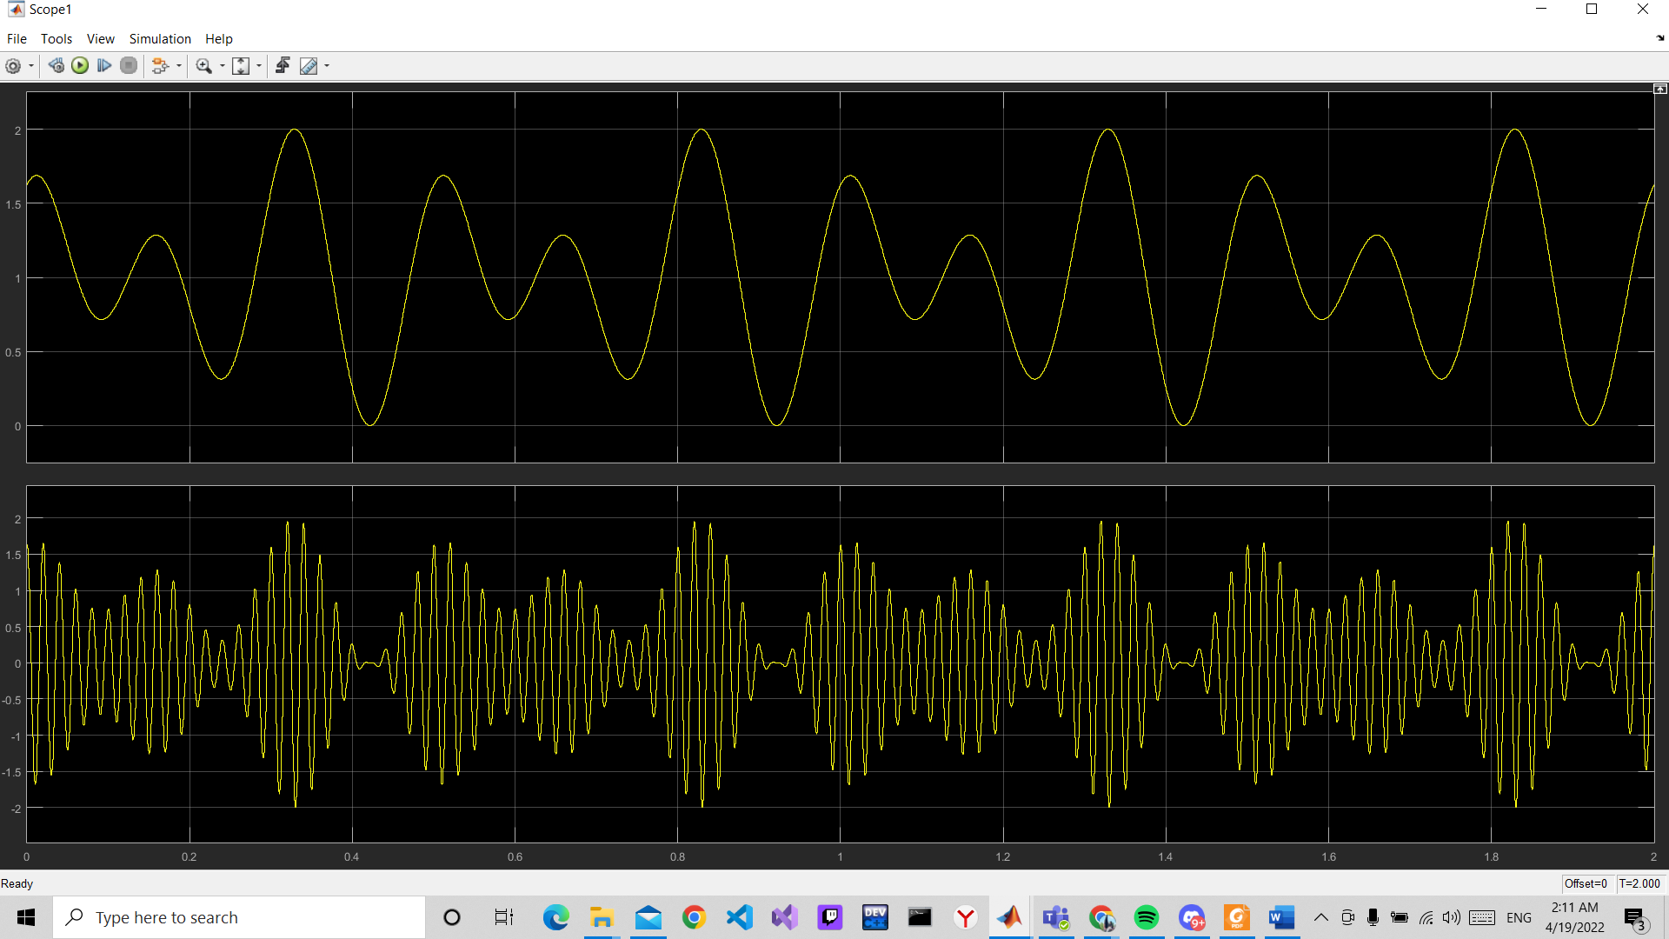

**Demodulation Output Scope:**

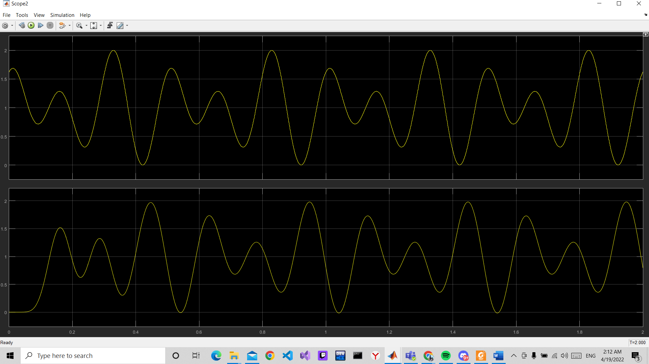

**Scope for original signal and recovered signal:**

